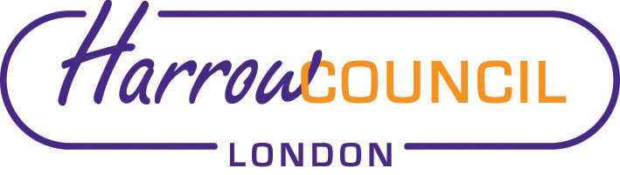
Harrow SACRE Meeting

Tuesday 28 September 2021 at 7.30 p.m.
To be held via video conferencing

Enquiries & apologies to:
Vivian Wright, Clerk to SACRE
vmwright@waitrose.com

Adviser to SACRE: Lesley Prior

Agenda
- Welcome:

- Apologies for absence:

- Minutes of the last meeting on 29 June 2021 (attached): to agree the minutes as a true record.

- Matters arising from the minutes

- Local and National updates

- Workforce data

- Collective Worship Policy

- Days of Religious Observance 2021-22

- Determinations
- Vaughan Determination

- Priorities for the year ahead

- News from Faith Groups relating to schools

- Any Other Business

- Bob Dawson

- Future Dates

- Thursday 2 December
- Tuesday 8 March 2022

